Conic Sections
Quiz: Ellipse Module

Name: ________________________

Instructions: Answer all the following questions in the space provided. Simplify all answers.

- For the following standard equations, identify the centre of the ellipse and the lengths of the horizontal and vertical axes.
a) x²/ 16 + y²/ 49 = 1 Centre: __________

Horizontal Axis: __________ Vertical Axis: ____________

b) (x - 1)²/ 4 + y²/ 25 = 1 Centre: __________

Horizontal Axis: __________ Vertical Axis: ____________

c) (x - 10)²/ 20 + (y + 7)²/ 144 = 1 Centre: __________

Horizontal Axis: __________ Vertical Axis: ____________

- An ellipse centred at the origin has a horizontal axis of length 10 and a vertical axis of length 8.
  - Sketch the graph of this ellipse on the graph paper provided.



  - Write the equation of this ellipse in standard form.

  - Write the equation of this ellipse in general form.

- An ellipse centred at (-3, -9) has a horizontal axis of length 2(5)^{1/2} and a vertical axis of length 16.
  - Sketch the graph of this ellipse on the graph paper provided.

  - Write the equation of this ellipse in standard form.

  - Write the equation of this ellipse in general form.

- Describe the effect that varying h and k in the standard equation
(x - h)²/ a² + (y - k)²/ b² = 1 has on the graph of an ellipse by completing the
following chart.

The Effect of h, k and r on the graph of (x - h)²/ a² + (y - k)²/ b² = 1.
Variable | The value of the variable decreases | The value of the variable increases | The variable = 0
h

k

- Describe the effect that varying a and b in the standard equation
(x - h)²/ a² + (y - k)²/ b² = 1 has on the graph of an ellipse by completing the
following chart.

The Effect of a and b on the graph of (x - h)²/ a² + (y - k)²/ b² = 1
Value of a and b | Effect on the graph of the ellipse
a > b

a < b

a = b

- The equation 16x² + y² - 160x - 16y + 400 = 0 defines an ellipse.
a) Determine the centre of the ellipse and the lengths of its horizontal and vertical
axes.

centre = ______________

horizontal axis length = _______________

vertical axis length = _______________

b) Sketch a picture of this ellipse on the provided graph paper.
7. An ellipse is defined by the standard equation (x + 9)²/ 9 + (y + 4)²/ 36 = 1 and by the
general equation 4x² + y² + 72x + 8y + 304 = 0.
a) Show that these two equations are equivalent.
b) Verify their equivalency by using the point (-12, -4).
8. If the equation Ax² + By² + Cx + Dy + F = 0 defines an ellipse, then what must be true about the values of the coefficients A and B?
9. Explain why a circle is a special ellipse.
10. An ellipse is formed when a double-napped cone is cut by a plane that is neither
parallel nor perpendicular to the vertical axis of the cone. Describe what happens to
the ellipse as:

  - The plane gradually tilts towards being parallel to the vertical axis of the
double-napped cone.

  - The plane gradually tilts towards being perpendicular to the vertical axis of
the double-napped cone.

c) The plane cuts the cone exactly perpendicular to the vertical axis.

11. The following ellipse is centred at (0, 0).
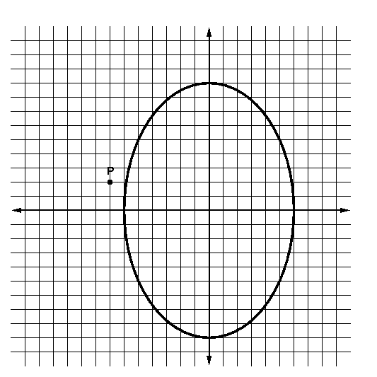

a) What are the lengths of the horizontal and vertical axes?
horizontal: _______________

vertical: _______________

b) Write the standard equation of this ellipse.

c) If the lengths of the axes remain the same, what would be the standard equation of this ellipse centred at the point P?

d) Sketch the graph of the translated ellipse in the above graph paper.

e) Describe how the ellipse was translated.

