Conic Sections

Quiz: Solving Equations Module

Name: ________________________

Instructions: Answer all the following questions in the space provided. Simplify all answers.

1. Which conic section is defined by the following standard equations.

a) x² + y² = 49 ______________________

b) (x - 4)²/25 - (y + 2)²/20 = 1 ______________________

c) x = 10(y - 8)² ______________________

d) x²/4 + (y - 5)²/16 = 1 ______________________

2. Draw pictures that shows the three different ways that a line and a circle can
intersect.

3. Two quadratic equations can intersect 0, 1, 2, 3 or 4 times. Draw a picture
that illustrates:
- a hyperbola and a circle intersecting once

b) a parabola and an ellipse intersecting twice.

c) a parabola and circle intersecting at 3 points

d) a circle and an ellipse intersecting at 4 points.

4. The following questions involve the equation 8x² + 5y² - 64x + 20y + 108 = 0.

a) Inspect the coefficients in the equation. State which conic section this
equation might represent and explain your answer.

b) Rewrite the equation in standard form to show that your answer in the
previous question is correct.

5. The following questions involve the equation x² + 12x - 3y + 39 = 0.

a) Inspect the coefficients in the equation. State which conic section this
equation might represent and explain your answer.

b) Rewrite the equation in standard form to show that your answer in the
previous question is correct.

6. A linear-quadratic system of equation consists of the equations:
y + (3/4)x = 0 and x² + y² - 25 = 0.

a) Sketch the graph of the  system on the provided  graph paper. | 

b) From the graph, estimate the solution of the system.

c) Use algebra to find the exact solutions to the system.

d) Show how to check your answer in part (c) by substituting the solutions
back into the original equations.

7. The equations x² + 4y² - 36 = 0 and x - 2y - 6 = 0 define a linear-quadratic
system of equations.

a) Sketch the graph of the
system on the provided
graph paper.

b) From the graph, estimate the solution of the system.

c) Use algebra to find the exact solutions to the system.

d) Show how to check your answer in part (c) by substituting the solutions
back into the original equations.

8. A quadratic-quadratic system of equations consists of the following:
4x² - y² - 7 = 0 and 2x² + 5y² - 9 = 0.

a) Sketch the graph of the
system on the provided
graph paper.

b) From the graph, estimate the solution of the system.

c) Use algebra to find the exact solutions to the system.

d) Show how to check your answer in part (c) by substituting the solutions
back into the original equations.

9. The equations x² + y² - 12 = 0 and x² - 4y = 0 define a quadratic-quadratic
system of equations.

a) Sketch the graph of the
system on the provided
graph paper.

b) From the graph, estimate the solution of the system.

c) Use algebra to find the exact solutions to the system.

d) Show how to check your answer in part (c) by substituting the solutions
back into the original equations.

10. In the figure below, a circle is translated over the fixed graph of an ellipse by
varying the value of h in the circle equation (x - h)² + y² = 4. For what
positive values of h does the circle intersect the ellipse at:

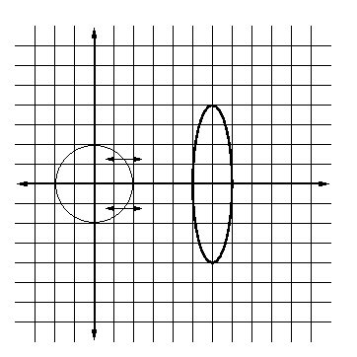

a) one point?

_____________________________________

b) two points?

_____________________________________

c) three points?

_____________________________________

d) four points?

_____________________________________

e) no points?

_____________________________________

