Conic Sections

Quiz: Parabola Module

Name: ________________________

Instructions: Answer all the following questions in the space provided. Simplify all answers.

1. Identify the vertex, opening direction and axis of symmetry of the parabola defined by:

a) x = 6y² c) x + 8 = -4(y - 10)²

b) y - 3 = 7(x - 5)² d) y = -(1/2)(x - 3)² + 9

 | a) | b) | c) | d)
Vertex
Opening direction
Axis of symmetry

- Convert each standard equation into a general equation of the form
Ax² + By² + Cx + Dy + F = 0.
a) y = 2(x + 4)² ___________________________________
b) x = (1/10)y² ___________________________________

3. A parabola opens upward and its vertex is located at the origin. The shape of this parabola can be described by a = 5.
a) Write the equation of this parabola in standard form.

b) Write the equation of this parabola in general form.

c) Sketch the graph of this parabola on the provided graph paper. | 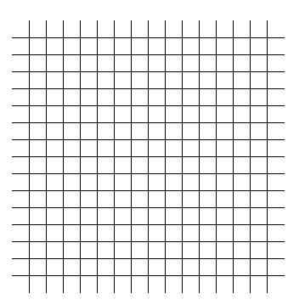

4. A parabola opens left and its vertex is located at (-9, 4). The shape of the parabola can
be described by a = -3/4.
a) Write the equation of this parabola in standard form.

b) Write the equation of this parabola in general form.

c) Sketch the graph of this parabola on the
provided graph paper.

5. Describe the effect of varying h and k in the standard equations y - k = a(x - h)²
and x - h = a(y - k)² on the graph of a parabola by completing the following chart.

The Effect of h and k on the graph of y - k = a(x - h)² and x - h = a(y - k)²
Variable | The value of the  variable decreases | The value of the  variable increases | The variable = 0
h

k

6. Describe the effect of varying a in the standard equations x - h = a(y - k)²and
y - k = a(x - h)² on the graph of a parabola by completing the following chart.

The Effect of a on the graph of x - h = a(y - k)² and y - k = a(x - h)²
Value of a | Effect on the Graph of the Parabola
|a| becomes farther from 0

|a| approaches 0

|a| = 0

7. If the equation Ax² + By² + Cx + Dy + F = 0 defines a parabola, then what must be true
about the values of the coefficients A and B?

8. A parabola is defined by the standard equation x = 12(y - 3)² and by the general
equation 12y² - x - 72y + 115 = 0.
a) Show that these equations are equivalent.
b) Verify their equivalency by using the point (19, 4).

9. The standard equation x = 4y² defines a parabola.
a) Sketch the parabola on the provided graph paper.

b) What will the graph of the parabola in part (a) look like if it is translated so that its
vertex is located at (-5, 8)? Sketch the graph of this parabola.

c) What will be the standard equation of the translated parabola?

d) Explain how the equation in part (b) describes the translation of the parabola.

10. A parabola is formed when a double-napped cone is cut by a plane that is parallel to
the generator of the cone. Describe what happens to the parabola when:

a) The plane moves farther away from the generator.
b) The plane moves closer to the generator.

c) The plane intersects the generator.
11. A parabola has one axis of symmetry. Explain why (or show how) it is useful to know
where this axis of symmetry is when sketching the graph of a parabola.

